Name:
Date:
Period:

Study Guide for 6.E.2.2 Assessment
Plate Tectonics, Earthquakes & Volcanoes

1. Alfred Wagener’s hypothesis of drift suggests that at one time
Word Bank
mountain | continental
Pangaea | animals

all land formed a supercontinent, named _.

2. The evidence of fossils, chains, certain plants and
support Wagener’s hypothesis.
3. It is generally considered that dinosaurs lived in warm climates, yet fossils remains are found in Antarctica. How can this be explained?

Word Bank

spreading | tectonics | young | dense | old
asthenosphere | transform | oceanic | divergent | plates
trenches | convergent | mountains | subduction

4. The main reason why Wegener’s hypothesis was originally rejected was because he could not satisfactorily explain what was causing the to move.

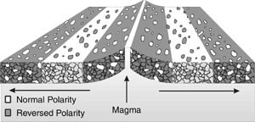
5. Years later the evidence of seafloor supported Wegener’s hypothesis on how land masses move due to magma creating new ocean floor at divergent boundaries. Scientists discovered ocean ridges which are underwater , and ocean which are narrow, long depressions with very steep sides.

6. They discovered rock near ocean ridges and rock near ocean trenches. There was also strips of reversed polarity rocks symmetrically, supporting growth in both directions away from the ridge.

7. The Theory of plate
states that the earth’s surface
(crust) is broken into about a dozen enormous pieces called plates.

8. The tectonic plates move about on the fluid-like upper mantle called the . There are two types of tectonic plates, continental (land) crust and (water) crust.

9. When a plate descends beneath another plate it is called . Oceanic crust is more
and can subduct under continental crust.

10. The Earth’s tectonic plates interact at boundaries. Name the three types of boundaries:
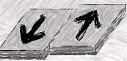

_

______________________ ______

_____________ _____________

 |  | ________________________________
Plates are moving apart from each  other | Plates are moving towards each other | Plates are moving side by side each  other

Diagrams
11. Match the following boundaries with their diagram (from graham cracker lab)

Transform Plate Boundaries are when
Divergent Plate Boundaries: Where plates are moving
plates move side by side with each other resulting in frequent earthquakes.
away from each other. This movement is found along the mid- ocean ridges where new crust material is being created.

Convergent Plate Boundaries are where one plate dives (subducts) under less dense crust to be recycled back into the asthenosphere. There are three types of convergent plate boundaries:
Type I Ocean – Ocean: Type II Ocean – Continental: Type III Continental –
when the ocean crust of two plates meet usually forming island arcs
when ocean crust subducts under continental crust forming mountain chains and volcanic activity
Continental: when two continental plates meet and buckle up forming large mountains.

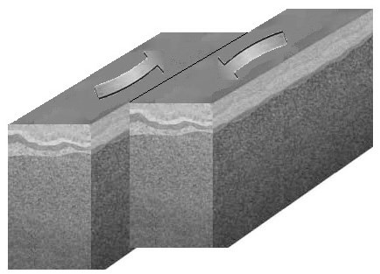
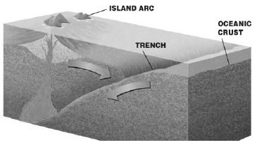
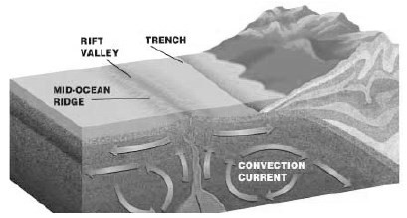
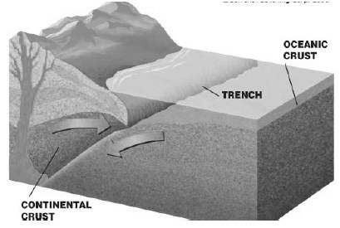
A C E

B D

Volcano

Volcano
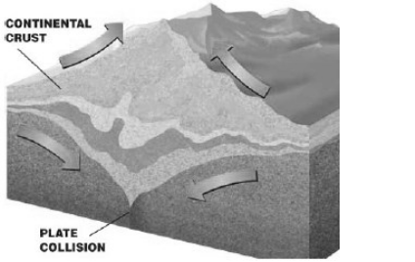

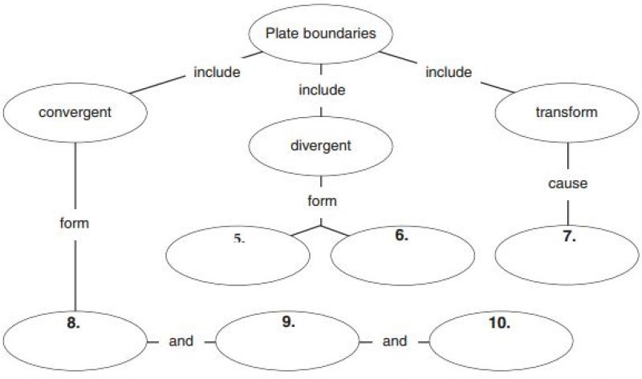
12. Complete the concept map below using the word bank
mid-ocean ridges | island arcs (volcanic islands) | major earthquakes
rift valleys | deep oceanic trench | mountains & most volcanoes

Volcanoes

Word Bank
convergent | explosive | ocean floor | sedimentary | volcanoes
water | hot spots | divergent | Ring of Fire | boundaries

13. Most volcanoes form at plate . 80% are found along boundaries, 15%
are found along boundaries and 5% are found far away from plate boundaries.

14. Converging plates form the most volcanoes! The subduction zone generates magma for the volcano from rock.

15. Rift volcanoes form from diverging plates. Most occur under where they create new

16. Volcanoes that do not form at plate boundaries rely on _. The Hawaiian islands are a good example because they are located in the middle of the Pacific Plate.

17. The also known as the Circum-Pacific Belt is a 25,000 mile stretch containing 90% of the world’s active _.

Earthquakes

Word Bank
fault | Seismic | epicenter | Circum | ridge push
mantle convection | boundaries | gravity/slab pull | focus | earthquake

18. A is a fracture in the rocks that make up the Earth’s crust. An is the shaking of the ground caused by sudden motions along faults in the Earth’s crust.

19. Most earthquakes occur at plate . 80% occur in the - Pacific Belt.

20. The is the point within the Earth where an earthquake rupture starts. And the is the point at the surface of the Earth directly above the focus.

21. A Wave transmits the energy released by an earthquake.

22. The underlying origin for earthquakes is movement of the plates. Earth’s plates can move due to three different
methods:
(1) : The slow creeping motion of Earth's solid mantle caused by convection
currents carrying heat from the interior of the Earth to the surface.
(2) (3)
: Weight of an elevated ridge pushes an oceanic plate toward a subduction zone.
: Cooled plates become dense and sink into the mantle due to its own weight.

23. Identify the following fault types.

Word Bank
Crust lengthens.
Popular at divergent boundaries

Crust shortens.
Popular at convergent boundaries

No change in crust length.
Popular at transform boundaries.

Reverse Fault

Strike-Slip Fault

Normal Fault
.
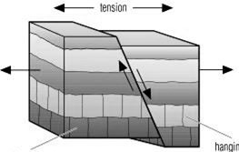
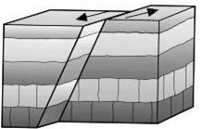
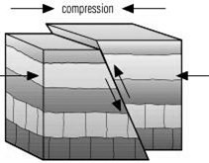
Seismic Waves
Please review the following information paying particular attention to the items underlined.

Types of Seismic Waves
There are several different kinds of seismic waves, and they all move in different ways. The two main types of waves are body waves and surface waves. Body waves can travel through the earth's inner layers, but surface waves can only move along the surface of the planet like ripples on water. Earthquakes radiate seismic energy as both body and surface waves. Traveling through the interior of the earth, body waves arrive before the surface waves emitted by an earthquake.
The first type of body wave is the P wave or primary wave. This is the fastest kind of seismic wave, and, consequently, the first to 'arrive' at a seismic station. The P wave can move through solid rock and fluids, like water or the liquid layers of the earth. Sometimes animals can hear the P waves of an earthquake. Dogs, for instance, commonly begin barking hysterically just before an earthquake 'hits'. Usually people can only feel the bump and rattle of these waves.
The second type of body wave is the S wave or secondary wave, which is the second wave you feel in an earthquake. An S wave is slower than a P wave and can only move through solid rock, not through any liquid medium.
Travelling only through the crust, surface waves are of a lower frequency than body waves, and are easily distinguished on a seismogram as a result as a very large looking wave. Though they arrive after body waves, it is surface waves that are almost entirely responsible for the damage and destruction associated with earthquakes. This damage and the strength of the surface waves are reduced in earthquakes where the focus is deep underground.

Finding the Epicenter
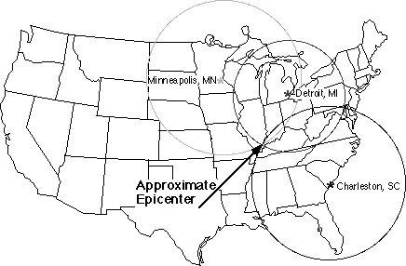
The epicenter of an earthquake is determined by triangulation. This means that seismic data is needed from at least three different locations, and where this data intersects tells us the epicenter.
When an earthquake occurs, it is recorded on numerous seismographs located in different directions. The seismograms at these locations show when the first
seismic waves, the P waves, arrive and then when the next waves, the S waves, arrive.
Knowing how fast each of these waves travel, scientists can calculate how far away the epicenter was from each seismograph. What they don't know is the precise direction the waves came from–the direction of the epicenter.
Scientists then must use a map. Around each of three seismograph locations, a circle is drawn on the map with a radius that equals the known distance to the epicenter. These three circles intersect at a single point. This point is the location of the earthquake's epicenter.

Measuring an Earthquake

Magnitude  (Richter Scale) | Requires a seismograph.  Seismographs are the most reliable measures of earthquakes. Uses Arabic numbers (1, 2, 3 etc.)
Intensity  (Mercalli Scale) | Based upon the reports of people who experienced the earthquake and observed the  destruction.  Uses Roman numerals (I, II, III etc.)

